NORTHERN EDUCATION DIVISION
2024 JUNIOR CERTIFICATE OF EDUCATION MOCK EXAMINATION
MATHEMATICS
(100 Marks)
Friday, 22 March Time Allowed: 2 hours
8:00 – 10:00 am

Question  number | Tick if answered | Do not write in these columns
1
2
3
4
5
6
7
8
9
10
11
12
13
14
15
16
17
18
19
20
Instructions
- This paper contains 13 printed pages. Please check
- Answer all the 20 questions in this paper.

- Scientific calculators may be used.

- The maximum number of marks for each Answer is indicated against each question

- All working must be clearly shown.

- Write your Name and class at the top of each page of your question paper in the spaces provided

- In the table provided on this page tick against the question you have answered.

- At the end of the examination, hand in your paper to the invigilator
- Convert 204₅ to base 10 (4 marks)

- Evaluate $\frac{x^{5-n}}{y-n}$ given that $n$ = 3, $x$= 2 and $y$ = 4 (3 marks)

- Given that the $n^{th}$ term of sequence is $8\left(n-2\right)+3(2n+9)$ and the last term of the sequence is 91. Calculate number of terms in the sequence.
(5 marks)

- In figure 1, MN = HZ, NZ = ZO and angle MNZ = angle OZN = 90º.
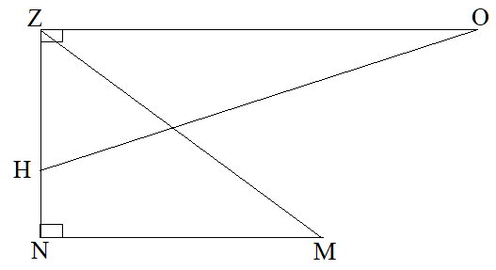
Prove that triangle NMZ and triangle ZOH are congruent. (4 marks)

- 15 kilograms of low-quality rice sold at k560 per kilogram is mixed with 20 kilograms of high-quality rice sold at k 800 per kilogram. What will be the price of the mixture per kilogram (6 marks)

- Factorize 6$x$² - 5$x$ +1 (4 marks)

- Make p subject of the formula $pq=m-p$ (3 marks)

- Evaluate $\frac{{2.3021}^{2}}{0.3211}$ using the logarithm ( 5 marks)

- (a) Solve the inequality, $2x> 4x-6$ (4 marks)

(b) Show the solution in 9(a) on the number line (2 marks)

- In figure 2 AB is parallel to CD, line GH intersect line AB at F and intersect line CD at E. Angle EFB = (2$y$ -30)º and angle and angle DEG = ($y$ + 40)º
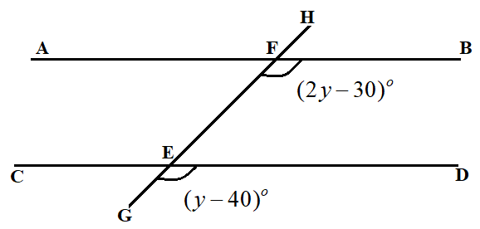
Calculate the size of angle GFB. (6 marks)

- Find the HCF of and (5 marks)

- Figure 3, is a triangle ABC, in which BC is parallel DE
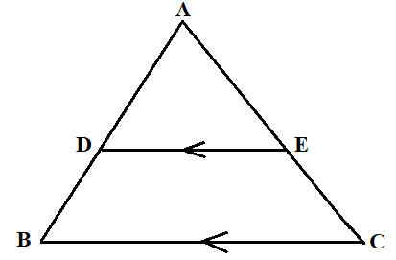
Show that triangle ADE is similar to triangle ABC (4 marks)

- The size of interior angle of a regular convex polygon is 150^{o.} Calculate the number of sides of the polygon (5 marks)

- Figure 4 is the pyramid with square base of length 10 m and slanting height of 13m.
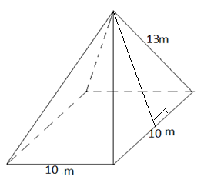
Calculate the total surface area of the pyramid (7 marks)

- Using a pair of compasses, pencil and ruler only, construct a triangle ABC, in which angle ABC = 60⁰, AB = 5cm and BC = 6cm (6 marks)

- (a) Complete the table of value for the linear equation of $y$ = 2$x$ + 1
(2 marks)
$$x$$ | -1 | 0 | 1 | 2 | 3
$$y$$ |  | 1 | 3 |  | 7

- Using a scale of 2 cm to represent 1 unit on both axes, plot the graph of equation $y=2x+1$ on the graph paper provided
(5 marks)

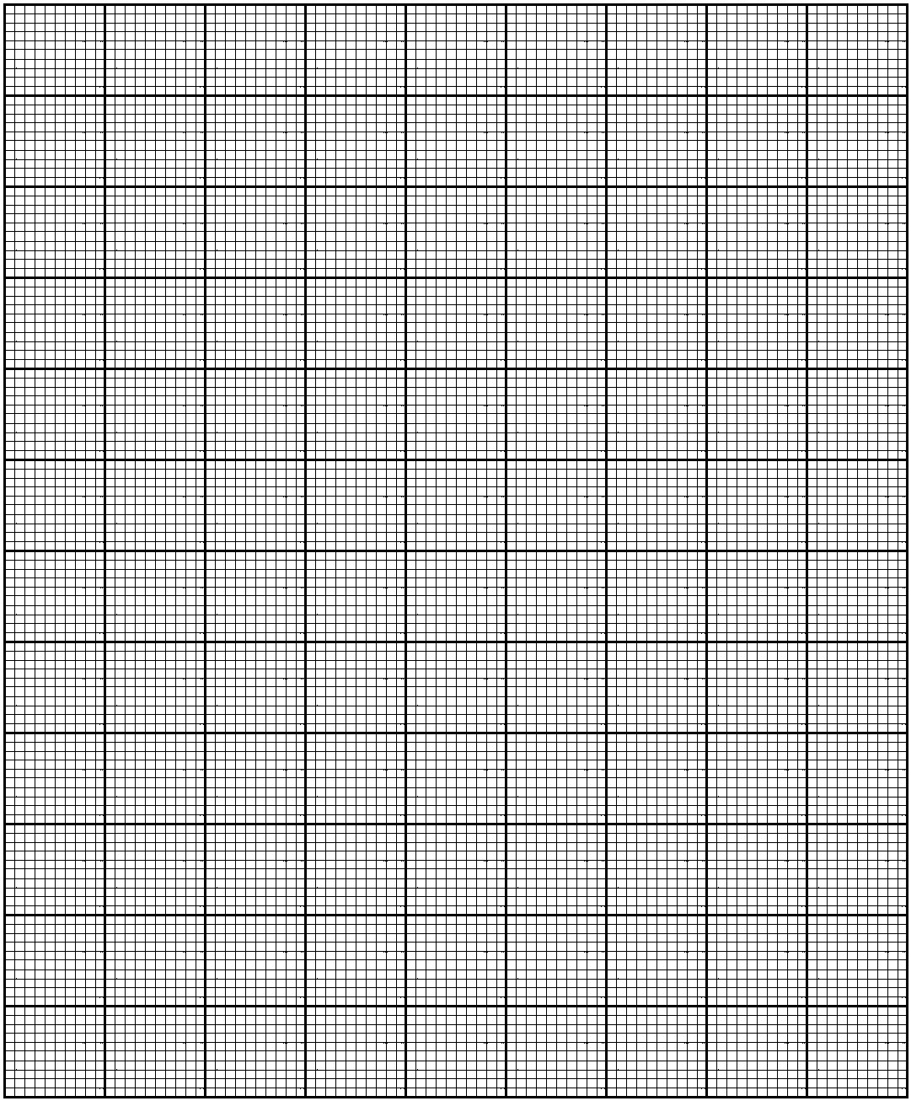
Continued/…
- The length of a rectangle is 3 cm longer than its width. If the area of the rectangle is 54 cm². Calculate the width of the rectangle (6 marks)

- Solve the simultaneous equations
2$m$ + 3$n$ = 3
$m$ – 2$n$ = 5 (5 marks)

- Mrs Gama went to collect her 11 years old kid at her mother’s house 4 km away from where she stays. The Distance – time graph below shows her journey to her mother.
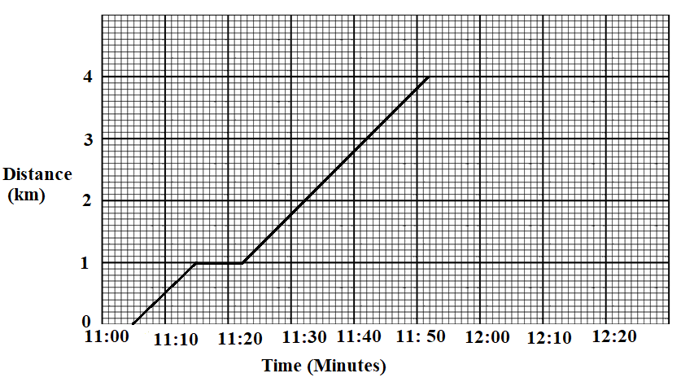
- For how long did the mother stop after covering 1 Km of her journey.
(1 mark)

- What was the mother’s average speed throughout the journey in m/min.
(4 marks)

- Table 1, shows data that was collected in the village.

Number of men in the village | Number of women in the village | Number of Boys in the village | Number of Girls in the village
134 | 156 | 108 | 102

Draw a pie chart to show the information. (4 marks)

END OF QUESTION PAPER
NB: This paper contains 13 printed pages.

